2.5 Logical view of the system
The logical view describes software responsibilities rather than physical hardware. It preserves the PHP MVC approach and connects the role-based interfaces to shared security controls and domain services. All named components below are design components; filenames in the traceability matrix are intended mappings, not files found in the repository.
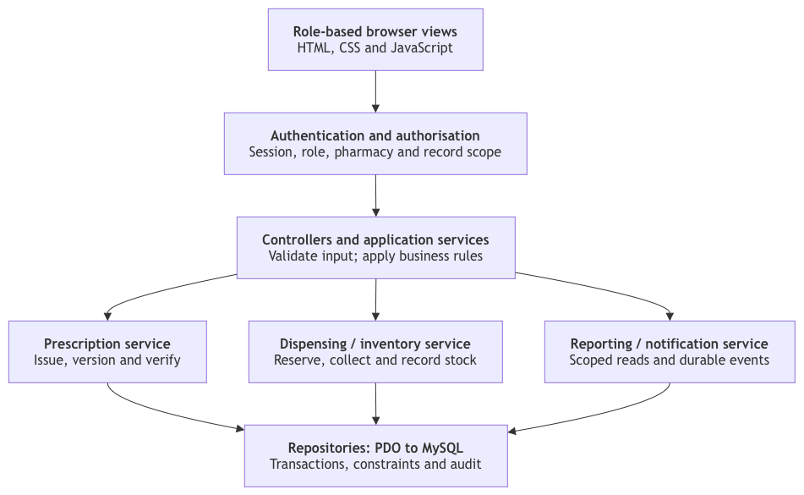
Figure 1. Proposed logical decomposition, consistent with the documented PHP MVC architecture.
Views display authorised data and collect user input. Controllers handle requests. Services coordinate clinical and inventory rules. Repositories perform parameterised database access. A transaction belongs at the service boundary because a collection changes several tables together.
Authentication, authorisation, input validation, encryption and audit handling apply across the application. Reporting reads only permitted records. Notification events are persisted with the core transaction and delivered after commit. AI and email/SMS failures must be visible but must not silently corrupt or reverse a completed stock transaction.

